The ‘OxiQuant S Oxygen Analyser’

The Purity Sensor is in multiple parts when removed from its packaging.
- OxiQuant S Display Head
- Oxygen Sensor
- Flow Diverter
- T Adapter
You may have some spare additional components in the box, such as a 22mm connector. These are not required but are recommended to be kept for potential future use.
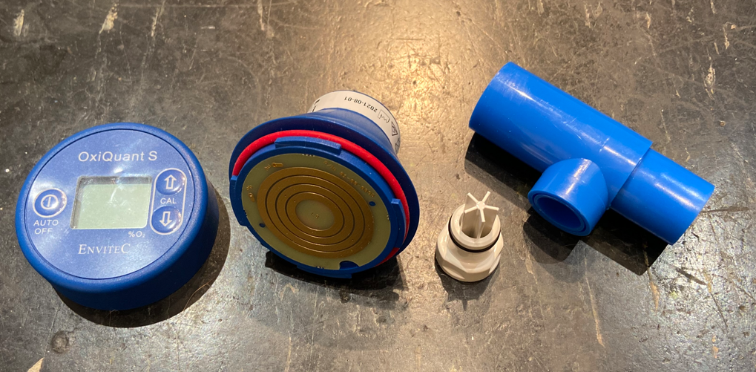
1 2 3 4
Attach the new Oxygen Sensor by turning the upper part of the device clockwise on the sensor. The Flow Diverter can then be screwed onto the thread of the sensor and then pushed into the side hole of the T piece.
Switch on the device by pressing the on switch. (Left-hand button labelled Auto Off)
The device can be calibrated to 20.9% O₂ in clean ambient air, it is then ready to be used for measurement.

Calibrating in ambient air
- Switch on the OxiQuant S
- Hold the OxiQuant S with the sensor side away from the body
- Read the oxygen concentration, and set it to 20.9% O₂ by pressing the calibration buttons. The value is increased by pressing the Up arrow and it is decreased by pressing the Down arrow.
The concentration of oxygen in ambient air is 20.95% O₂. This is why the calibration value is set to 20.9% O₂ Ambient Pressure, humidity and temperature can have an effect on the display value. So please consider where you complete your calibration.
- The device is ready to take a measurement.

Calibration to 100% O₂

Should you wish to ensure your device is calibrated to 100%, you will require a medical oxygen cylinder and connection that does not go through any equipment such as a vaporiser. This should not be required between ‘Certus Biomed’ service / calibration visits. However, instructions to complete this are supplied in the box with the product. So please ensure you keep the instruction manual in a safe place.

Ready to measure

Now that you have assembled the device, and turned it on, it has completed its auto checks and is displaying an ambient O₂ reading. You are ready to test your Oxygen Concetrator(s)

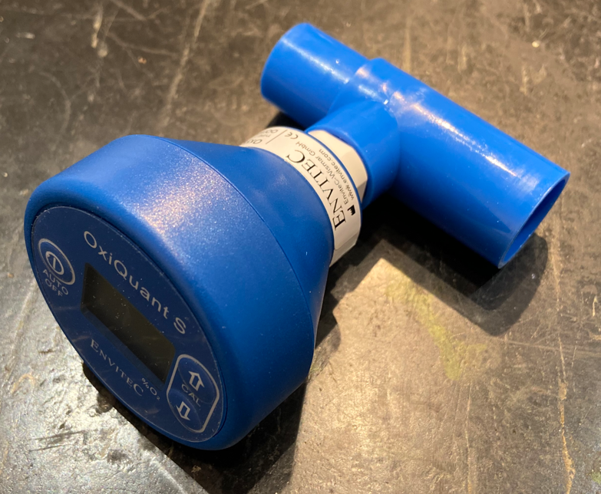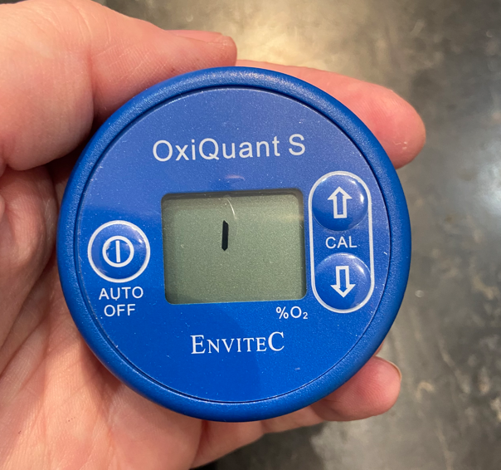

Turn on your Oxygen Concentrator.
Remember that Oxygen Concentrators will take 3 -5 minutes to warm up before it starts producing circa 93% Oxygen. Some units may give you an indication of when they are ready for use.
Piped concentrator systems may have a reserve cylinder and be ready much quicker, however, note that long-term use or high flow will result in purity levels dropping.

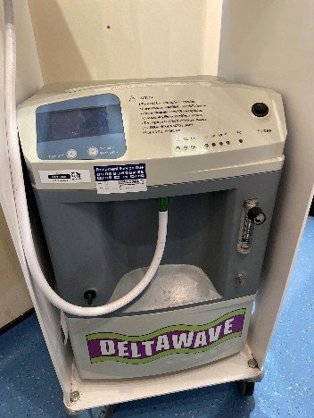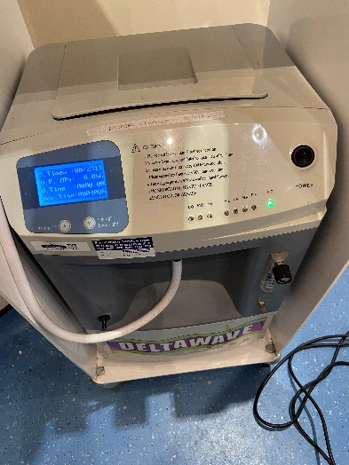

Whilst your unit is warning up, it is good practice to check that your backup Oxygen Cylinders are set up and ready, that the content is not expired and that all connected equipment is in good working order. All staff should be trained in what to do in the event of a power or concentrator failure, so you know how to switch to your cylinder supply safely and easily. Concentrators should also have an in-date servicing sticker, within the last 12 months.
For the purpose of checking the Oxygen Purity, you then want to set the main flow meter to 2 L/Min.

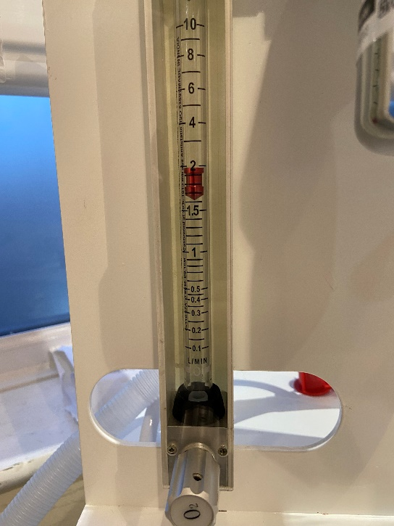
The Vaporiser should be in the ‘Off’ position, this is not only to ensure there is no accidental exposure to anaesthetic gas, but it could affect the reading and potentially damage the sensor.
For standalone units, or piped wall-mounted units you can now push the Purity Sensor directly onto the outlet.

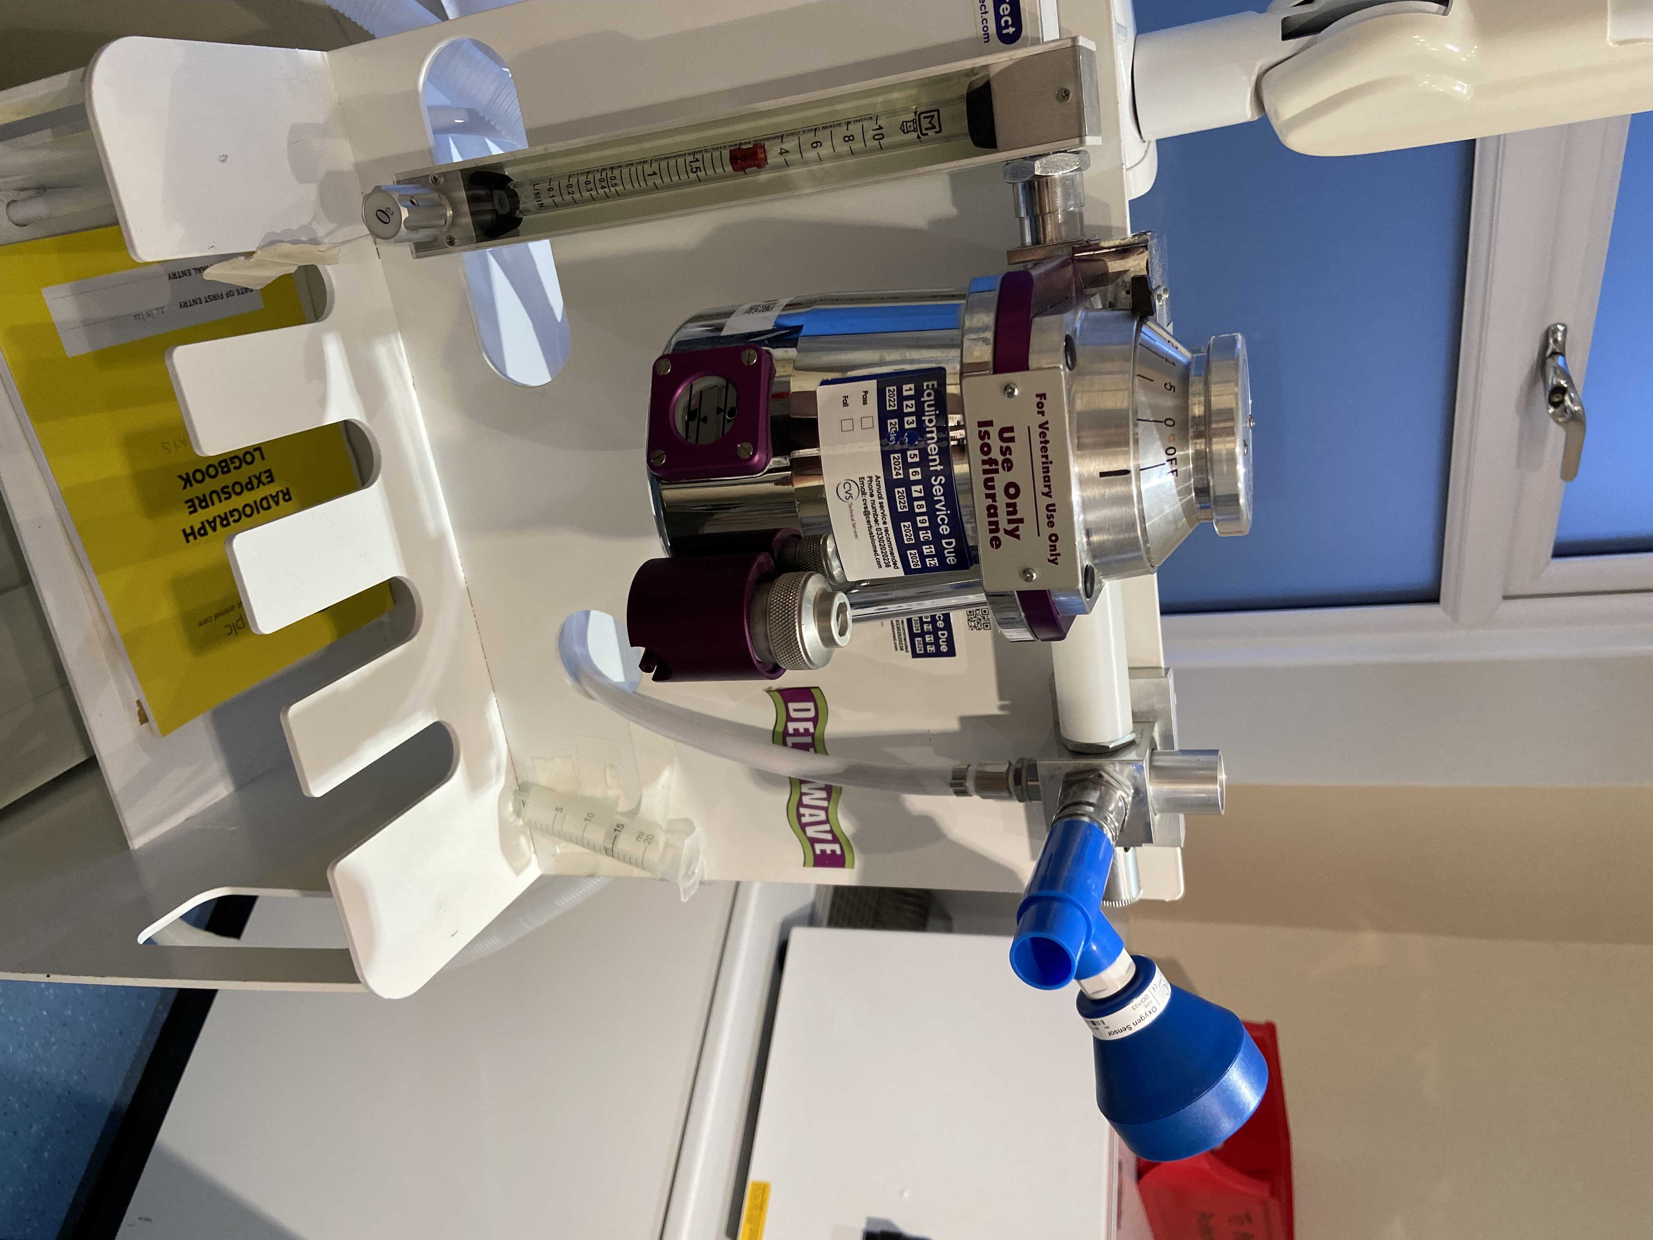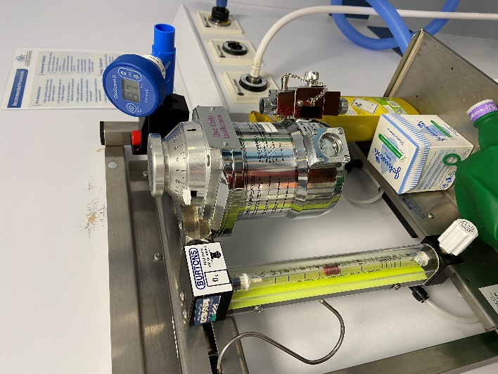

Get into a position where you can clearly see the LCD screen and you will see the % O₂ level rise, within a few seconds levelling out. When the display number settles, this is the measured reading of your concentrator.

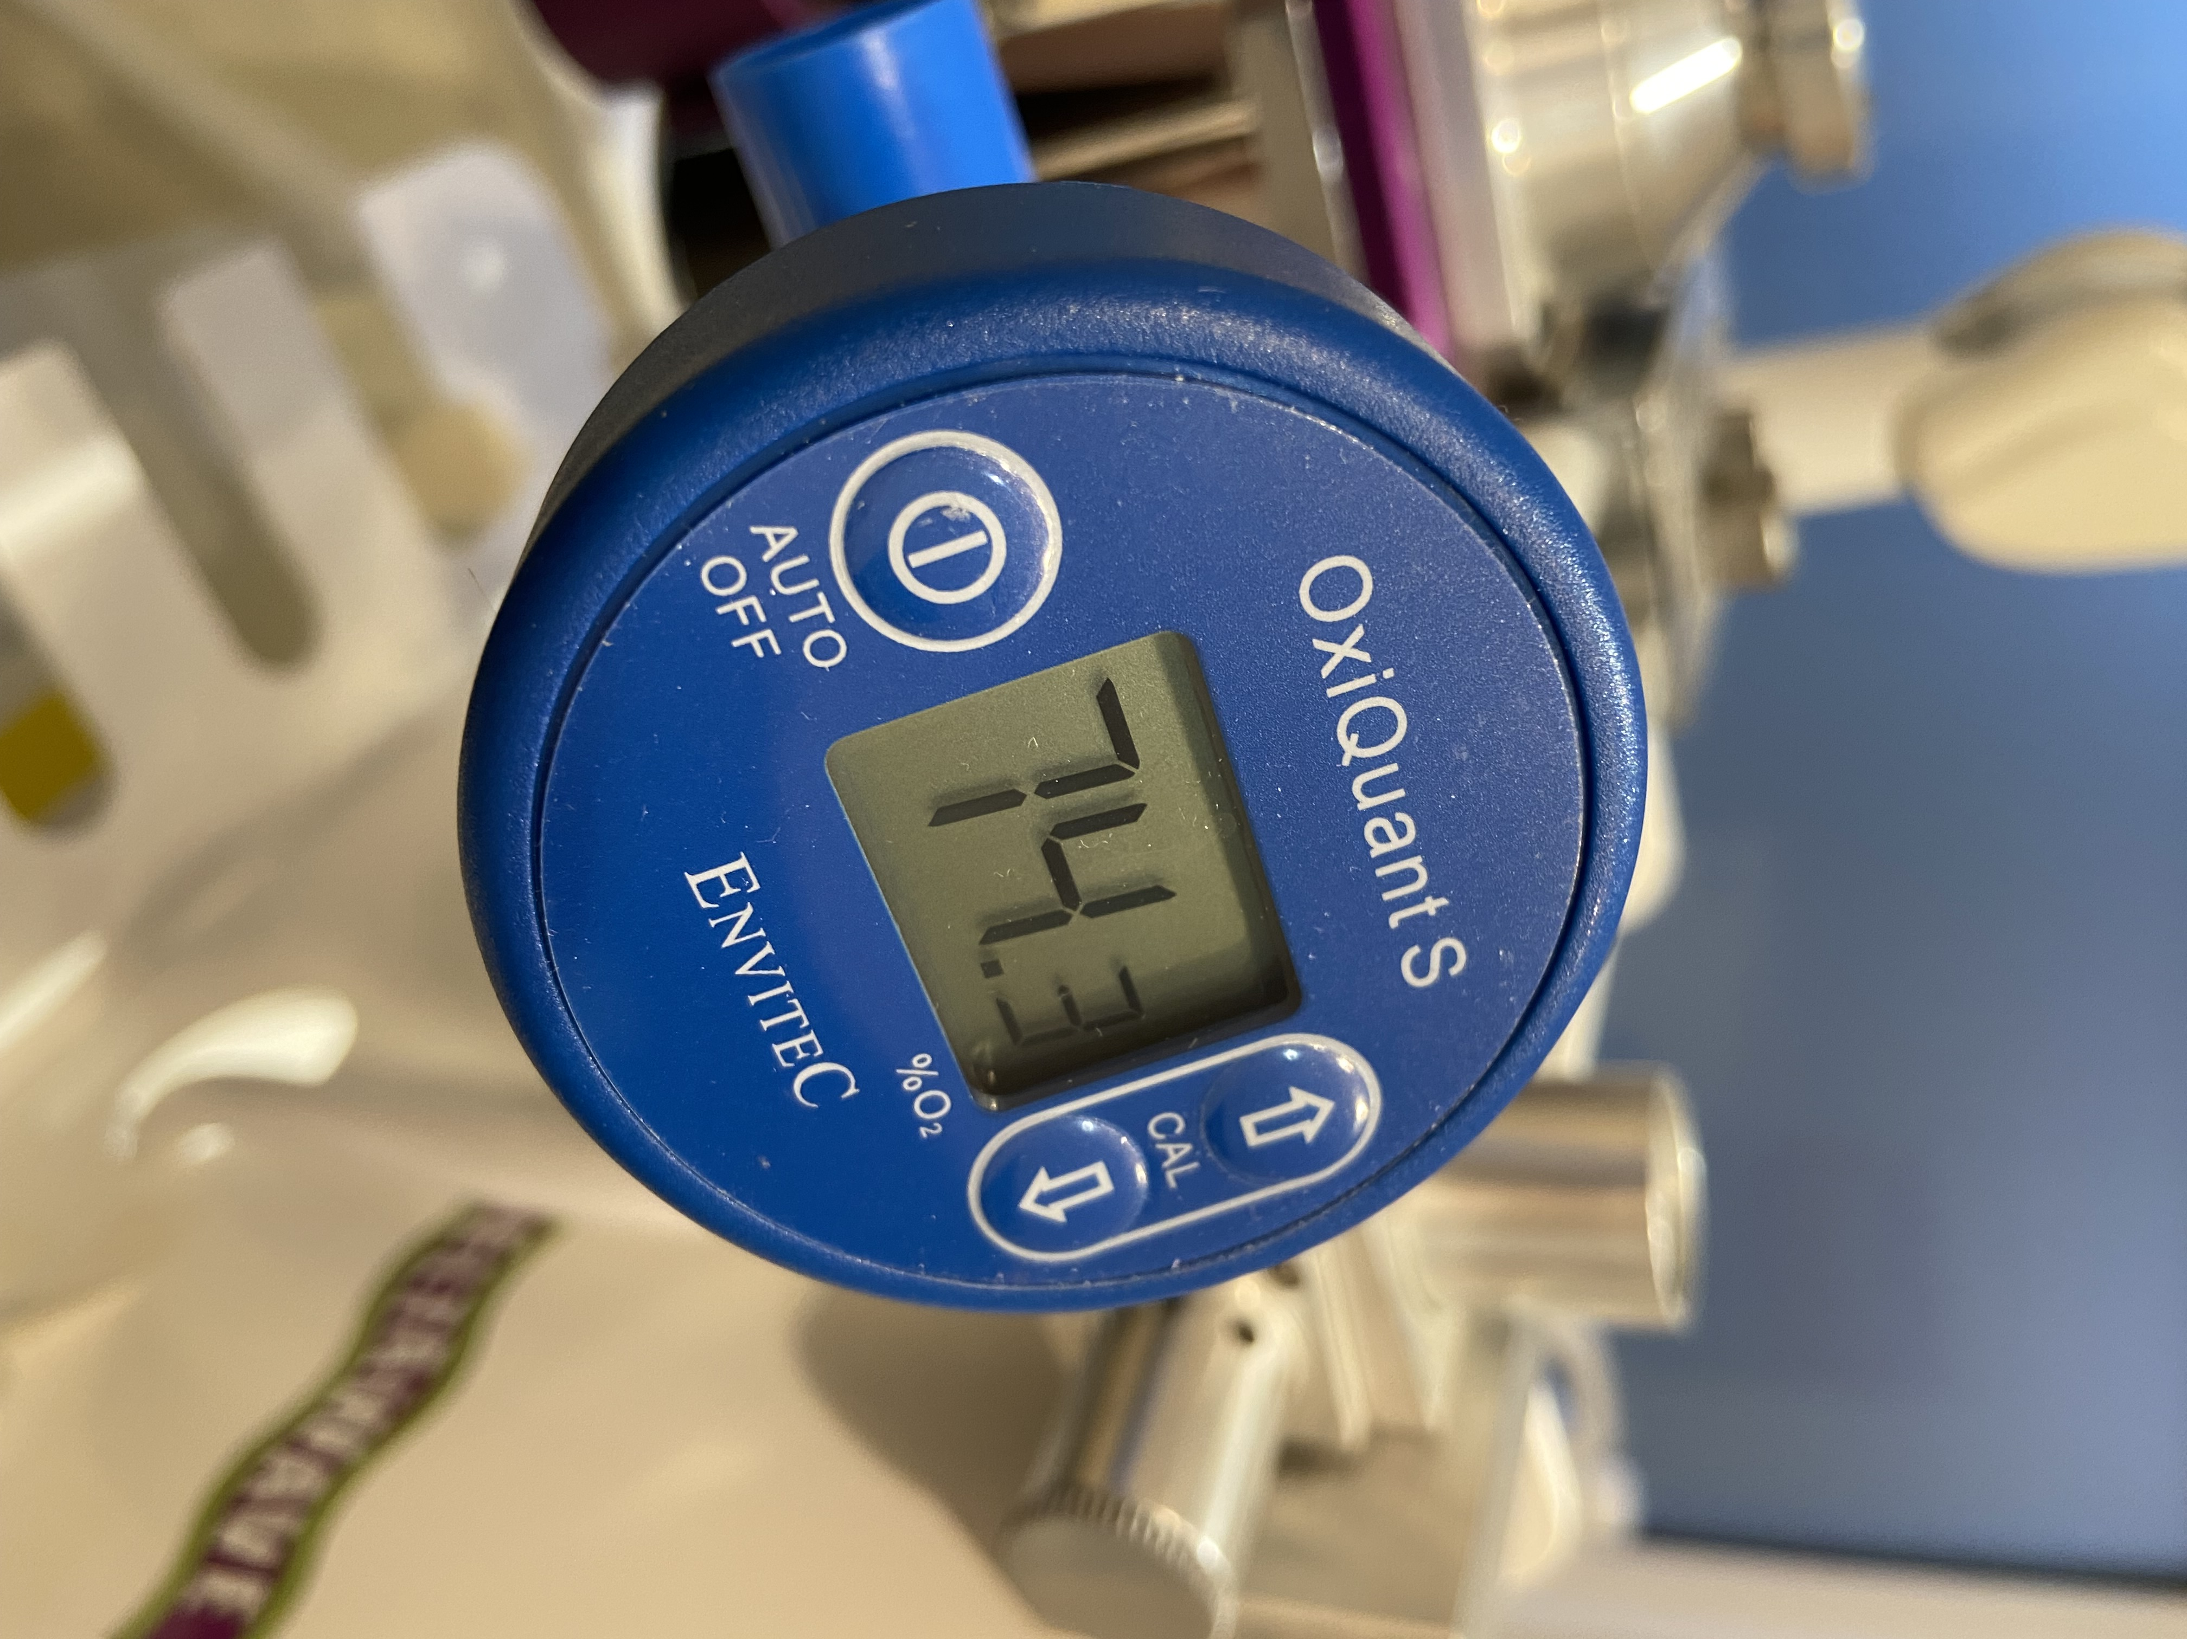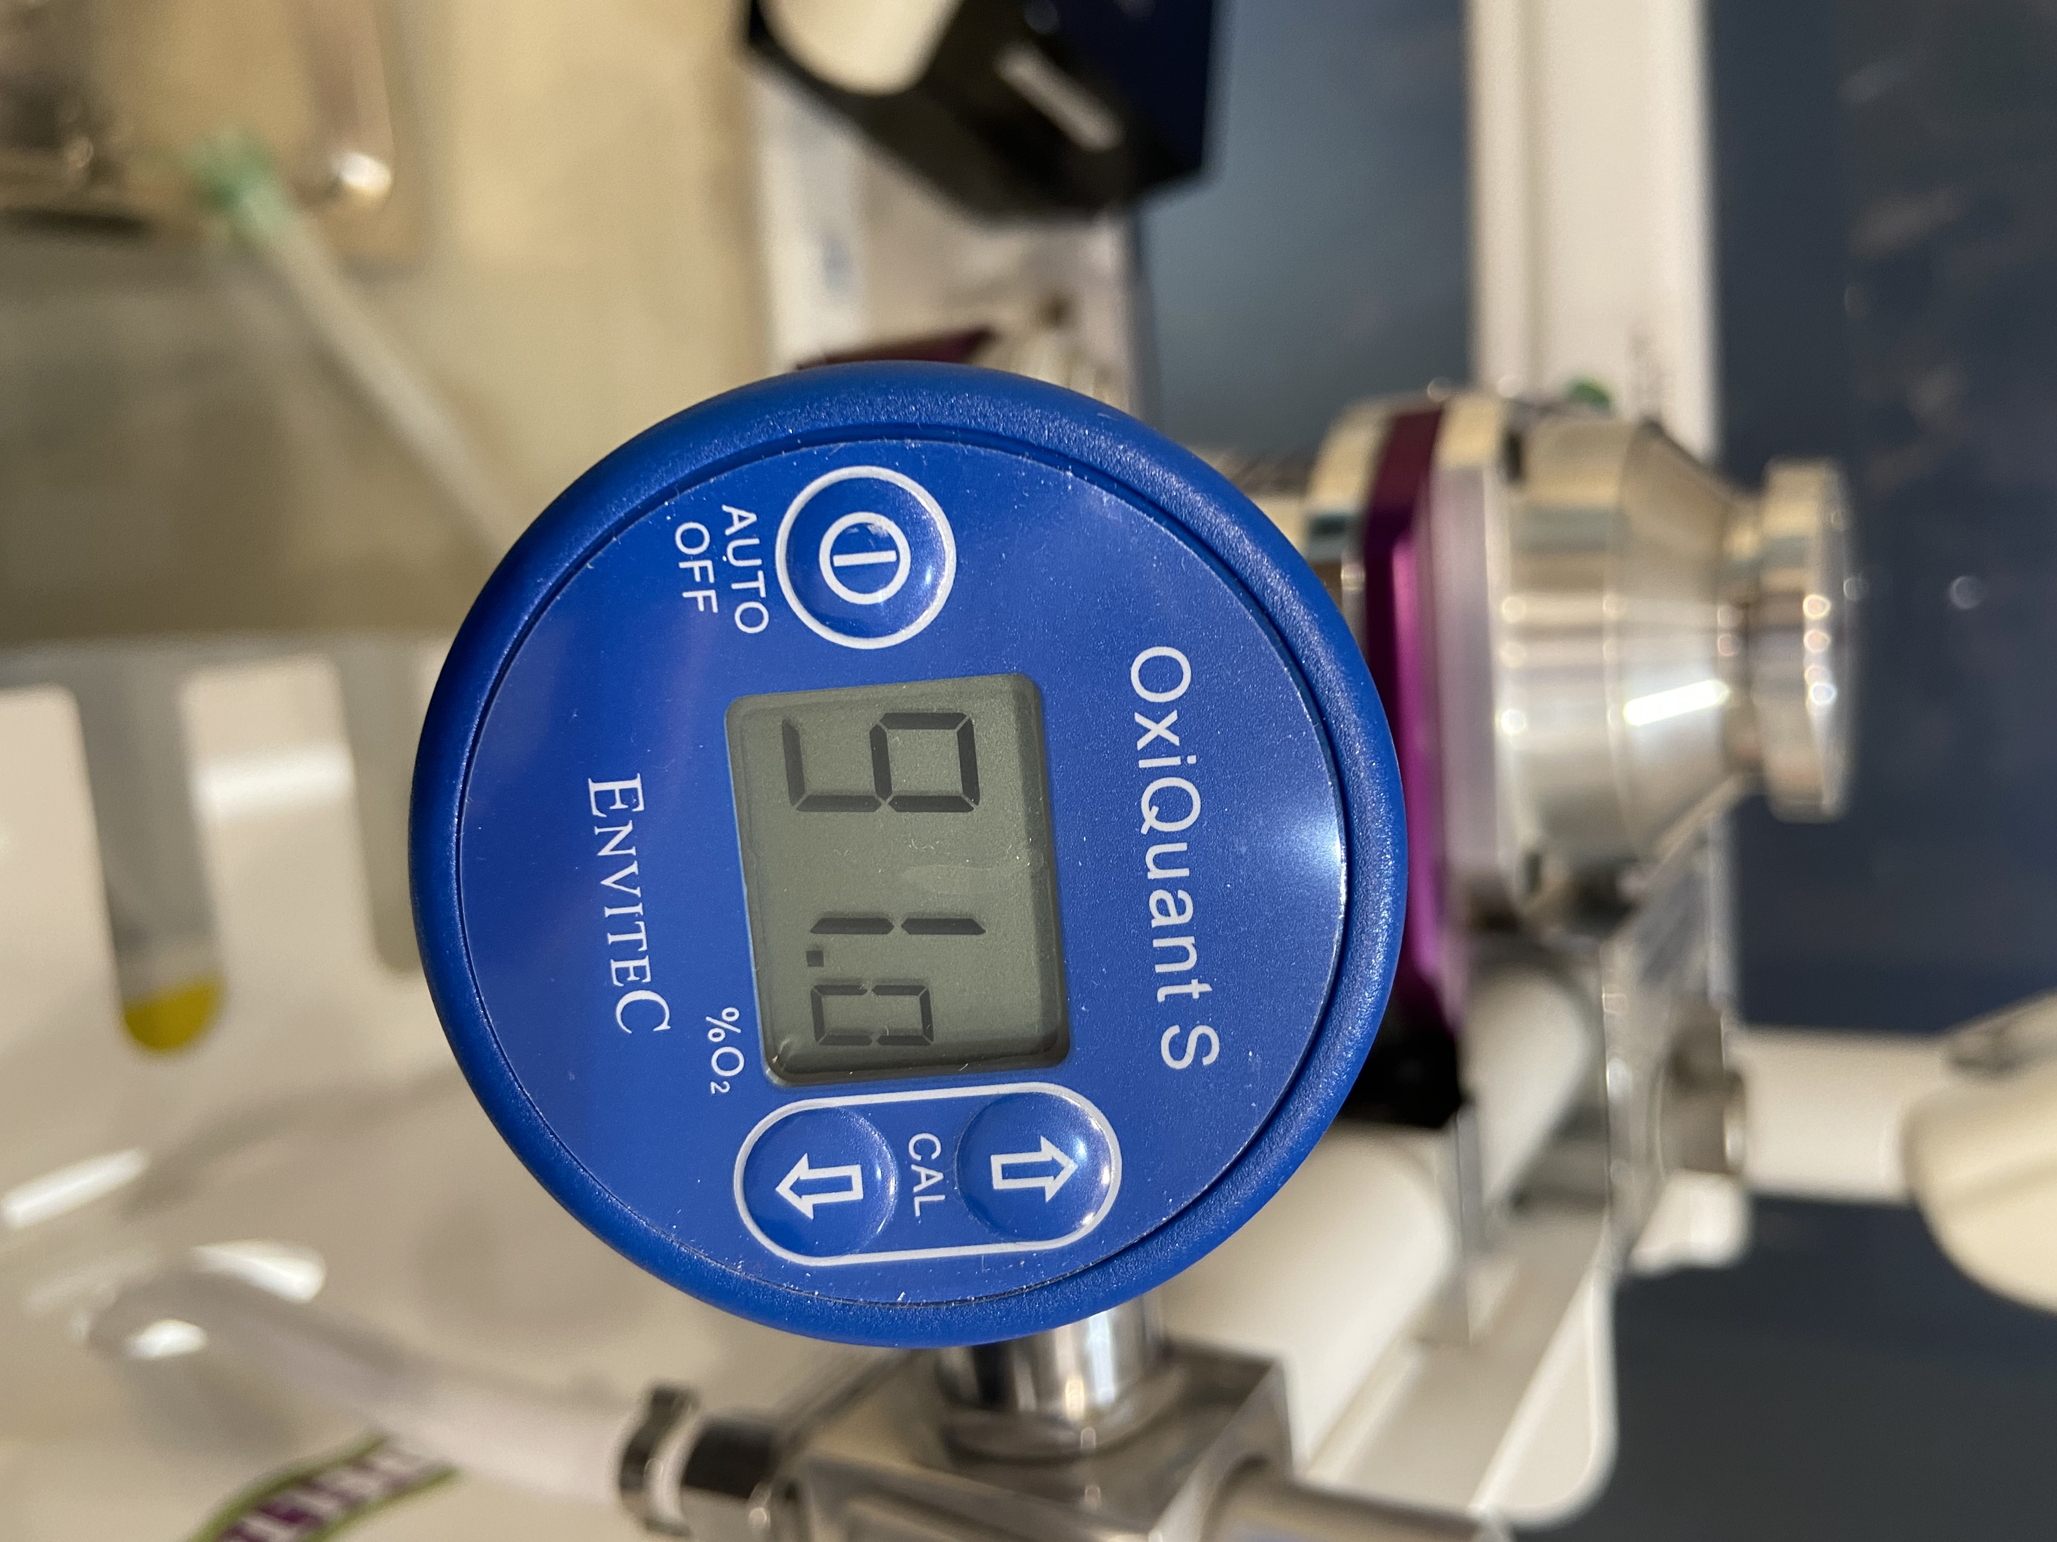

Please note that Oxygen Concentrators are designed to give 93% O₂ + or – 3%.

The reading that you obtain should be reported on SurveyMonkey here or scan the QR code below. 

Should the output go below 85% O₂, ‘Certus Biomed’ should be informed as a matter of urgency. Then a clinical decision made if to change to your Oxygen Cylinder for supply. Then monitor your cylinder stock levels closely.

