**Envitec OxiQuant S Oxygen Analyser**

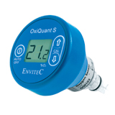

Used to determine oxygen concentration, delivered by oxygen concentrators.

The unit is supplied with both a T connector and an oxygen stem connector.

The device is simple to use and gives fast accurate results.

* Flexible manual calibration
* Auto-off (after 3 minutes)
* Response time: < 13 seconds to 90% of value
* Sensor (with integrated battery) can be replaced

Standard accessories included:

* OOI103 Oxygen Sensor (Part Number: 0110660)
* `T` Adapter (Part Number: 0120100)
* Flow Diverter - 15 mm O.D. (Part Number: 0120092)
* Connector - 22 mm oxygen stem (Part Number PP1968)