Setup of Anaesthetic Circle Absorber

1. 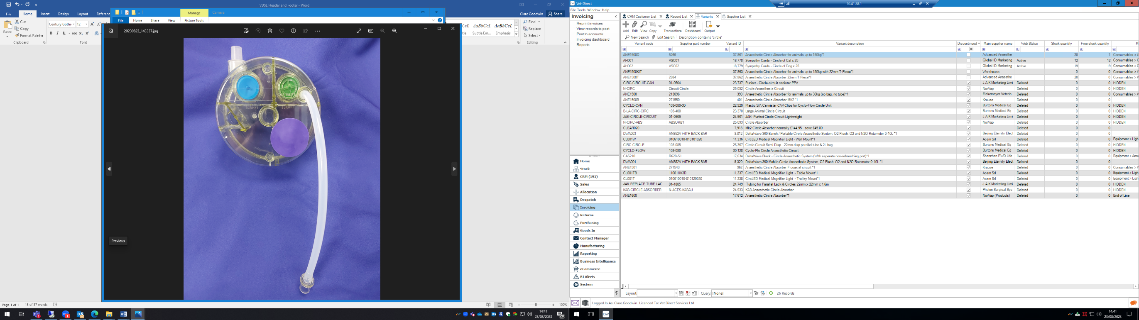Your Circle absorber will arrive with plastic tubing attached. Please remove this from the Circle. This can be removed by gently pulling the tubing.

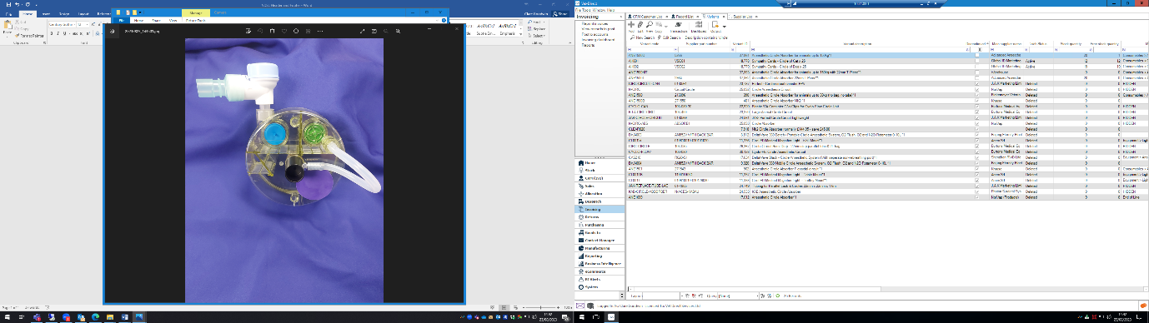

1. Place the tubing with the black connector (product code **2984**) into the back of the circle circuit. This connector allows the Circle absorber to be attached to the oxygen outlet of the anaesthetic machine.

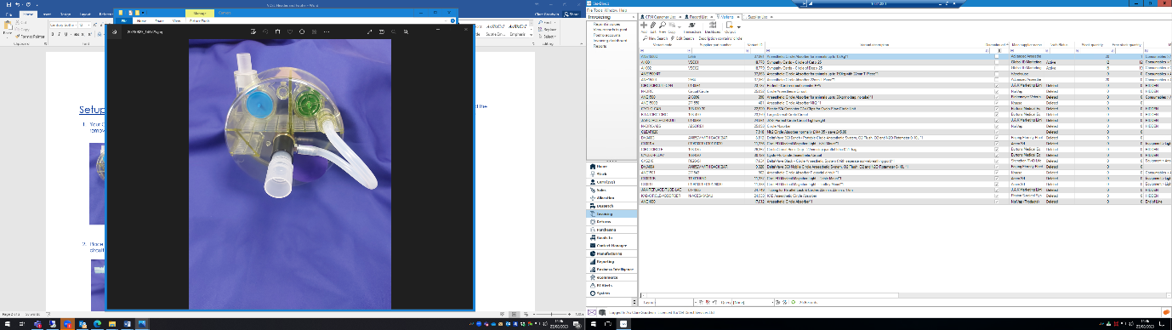

1. If there is not enough space for the Circle absorber next to your vaporiser, attach connector product code**1961** to the back of the Circle. This should allow the Circle absorber to be attached to the oxygen outlet. A longer connector is available.

V1 August 2023