

|  |
| --- |
| ***Air-Wave III LED Dental System*** |
|  |

# Air-Wave III LED Dental System:

Air-Wave III Chassis on Wheels (Height – 750mm; Width – 490mm; Depth – 490mm)

Silent Oil Compressor

Compressor Oil

Handpiece Control Box

2 Litre Water Bottle

Handpiece Foot Pedal

High Speed Turbine Handpiece 400,000rpm (Highspeed Drill)

Slow Speed Air Motor 0-5,000rpm

E-fitting Slow Speed Straight Handpiece (Polisher Handpiece)

Prophy Angle (Polishing Cup) Attachment

Prophy Paste

Prophy Cups

Prophy Cup Finger Rings

Set of Assorted Burs

Safety Glasses

Air Motor/ Turbine Lubricating Oil

E-Fitting Lubricating Aerosol

E-Fitting Lubricating Aerosol Nozzle

Piezo De-Scaler

Set of De-Scaler Tips

Water Hose for De-Scaler

# Installation Instructions

Unpack your Air-Wave III LED dental system. It will arrive with you fully assembled and virtually ready to go. There are a few small steps that you will need to do before being ready to use your new dental system.

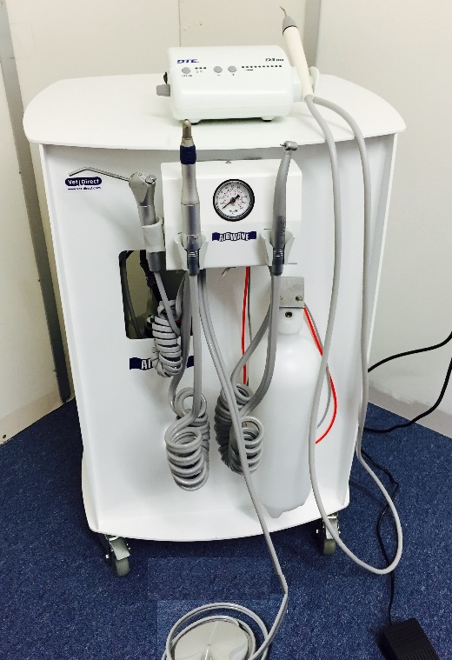 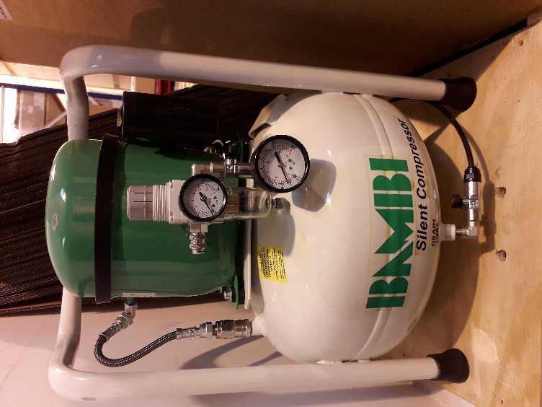

Front Back

Note the orientation of the handpieces and holders along with the   
3-in-1 Syringe Fig. 1. Ensure correct placement/ attachment of handpieces to hoses.  
  
**Ensure the handpieces are oiled and primed before use.**

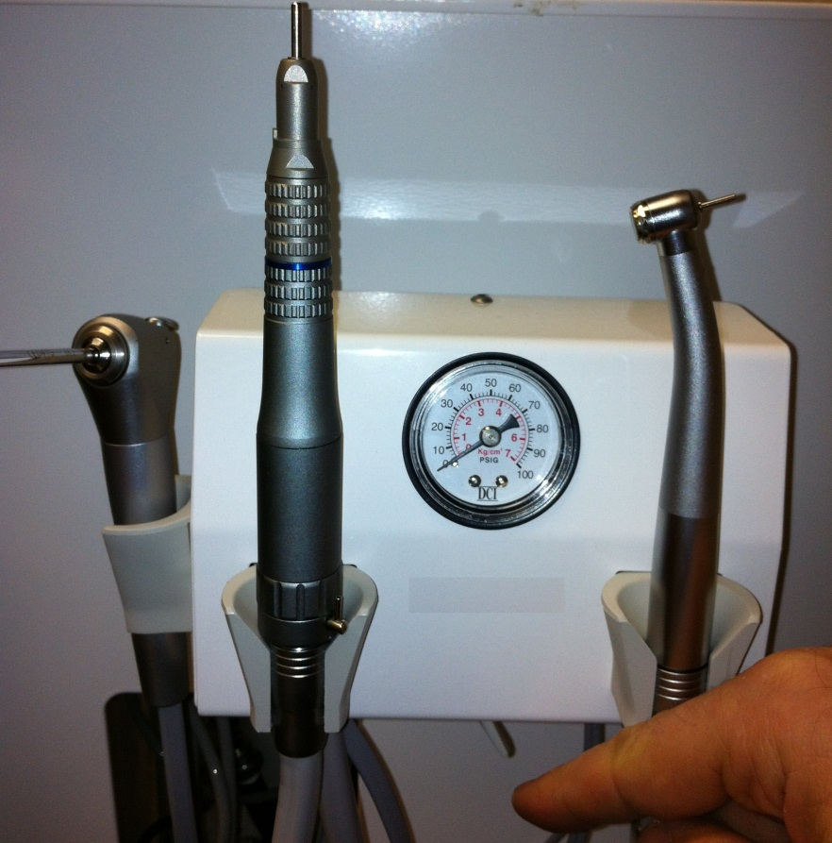Fig. 1

High Speed Turbine Handpiece (on the hose to the right)

Slow Speed Air Motor with

E-Fitting Slow Speed Straight Handpiece (on the hose to the left)

3-in-1 Syringe

You will need to locate the red de-scaler water line – which has the white plastic quick release (twist) fitting. Feed the end through the small circular hole behind/ to the right of the control box and then up through the slot in the top of the chassis. Attach the tubing to the D3 DTE de-scaler water supply inlet (Fig.2) Also, set up the de-scaler foot pedal, handpiece, scaler tip and power supply.

Fig. 2

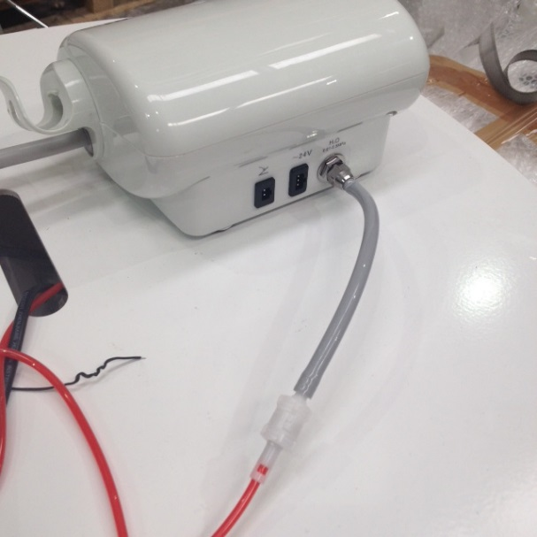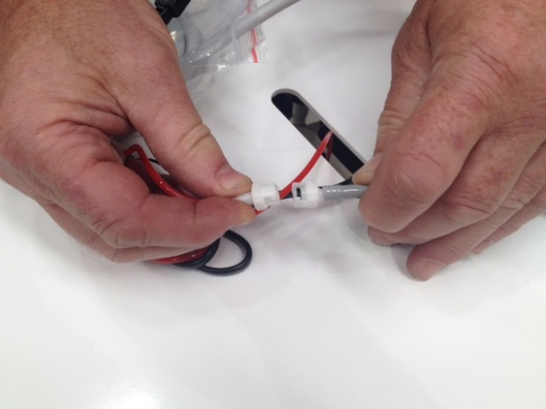

Attach water line to scaler

Quick Release Scaler Wate

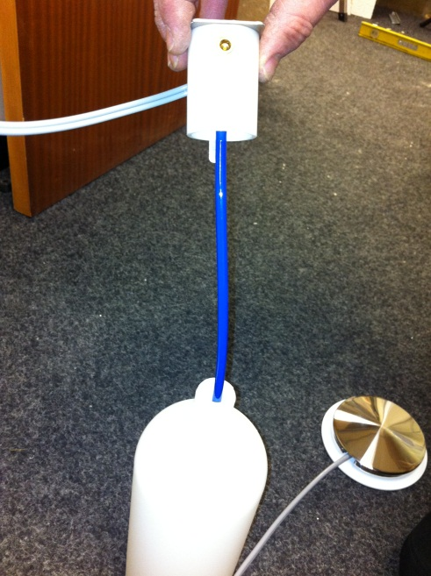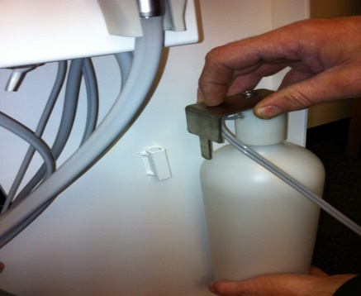

Fill the water bottle with purified or distilled water and hang up on the hook/ bracket underneath the handpiece control box.

Start up the compressor (Note: pressure levels are set up pre-delivery)

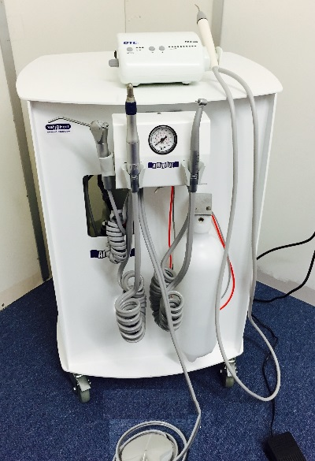 Fig. 3 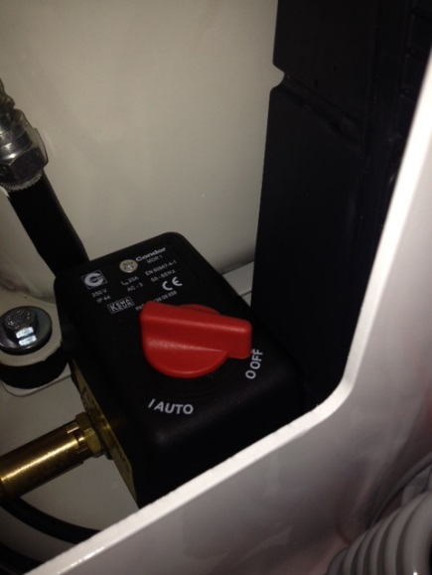 Fig. 4

Twist Switch from Off to Auto/On

Compressor Start Switch

The compressor will now start to build up pressure and automatically cut off when the compressor receiver tank pressure dial reaches 8 bar. The output pressure adjustment valve (Fig. 5) has been calibrated ready for use – please do not alter this without instruction from one of our engineers or a member of our technical support team.

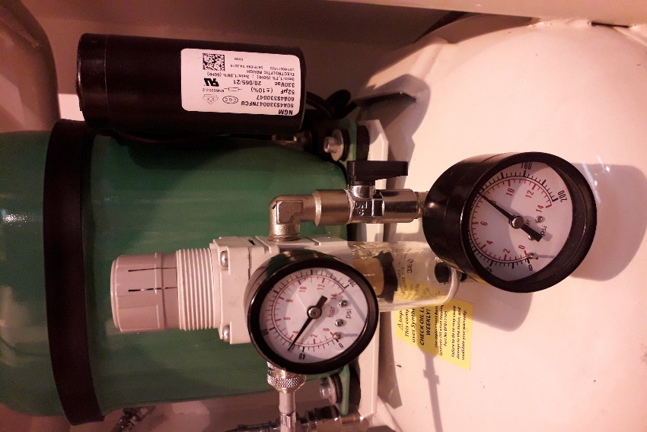Fig. 5

Compressor receiver tank pressure dial – this will fluctuate between 6 Bar and 8 Bar - when the lower level is reached the compressor will automatically start to run and build pressure back up to 8 Bar.

Ensure the Isolation Valve is turned on (pointing down/ vertical)

Output Pressure Adjustment Valve

Adjustable Output Pressure Dial

**Ensure the Isolation Valve is turned on (vertical)** – so that air can flow to the outlet (Fig. 5)

OPERATIONS and FEATURES

The control/ selector switches are located on the base of the control unit.

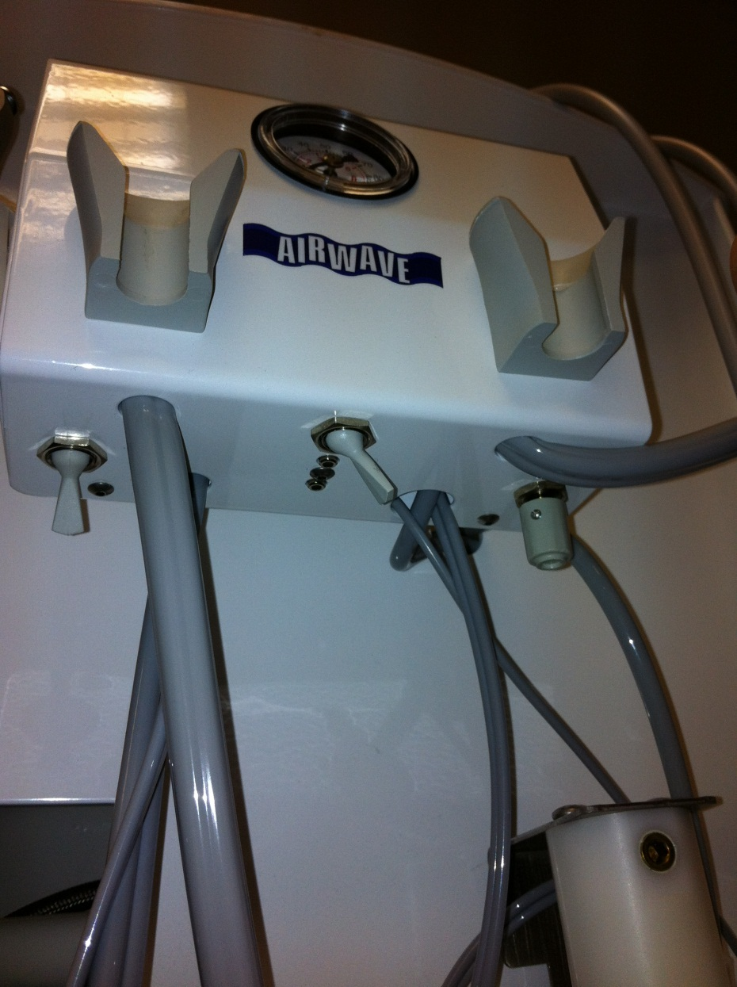Fig. 6

Water On/OFF Toggle

Current position is OFF (no water)

Forward position is ON (water to high speed handpiece only - the E-Fitting slow speed handpiece does not receive water)

Water Flow Control Dial (controls water flow to the high speed handpiece only - the E-Fitting slow speed handpiece does not receive water)

Handpiece Selector Toggle - switches between low speed and high speed handpieces. Current position shows the high speed option has been selected for use

#1

#2

* Handpiece pressure adjustment screws are located in the centre rear, behind the handpiece selector toggle. The pressure settings are factory set, however, adjustments can be made using a 3/32” hex/Alyn key to adjust hand piece pressures. The front adjusting screw is for handpiece #2 (High Speed) and the rear adjusting screw is for handpiece #1 (Low Speed). Handpiece pressures should be adjusted in accordance with the manufacturer’s recommendation – do not alter these without instruction from one of our engineers.
* The pressure gauge on the front of the handpiece control box indicates the operating pressure of the selected handpiece when the foot pedal is pressed. This should be around 31psi – if this is not the case and your handpieces are not functioning correctly please call our service department to speak to our engineer - ***0800 0683300 – Option 2***

***Please CALL for assistance before making any adjustment to the factory set pressures – 0800 0683300 – Option 2***

### 3-in1 Air/Water Syringe

The 3-in-1 syringe can provide air only, water only or a combination of air and water. To operate the syringe simply press either one or both of the two small buttons on its head.

The syringe tip is removable by depressing the outer ring then pulling the tip away from the syringe head. The tip can then be cleaned/ autoclaved at 134°C.

### Filling with Water

Before filling the water bottle it is first important to depressurise the bottle. This can be done by setting the water supply switch to off (Fig. 6) and shutting off the isolation valve (Fig. 5), then press the air button on the 3- in-1 syringe to release any air left in system. Gently unscrew the water bottle from the housing, and refill with either purified or distilled water. Once you have reattached the bottle, remember to turn the isolation valve back to the on position (vertical/ pointing down - Fig. 5). PLEASE NOTE: Failure to turn the isolation valve back to the on position will mean that there will be no air to your handpieces and they will cease to function.

### Foot Control

Handpiece operation is controlled with the handpiece foot pedal.

NOTE: The De-Scaler has its own foot pedal (BLACK).

### Cleaning and Maintenance

DO NOT use powdered cleansers, scouring pads or abrasive scrubbers on any of the finished metal surfaces on the unit. Sodium hypochlorite/ bleach or products containing alcohol will also damage/ discolour these surfaces. A suitable veterinary disinfectant at the correct dilution rate is appropriate.

### Dental Unit Water Line Maintenance

A chlorhexidine dental solution can be added to the water bottle which will help prevent a build-up of bacteria within the system. You may wish to ensure the system is flushed through with this on a weekly basis.

### **HANDPIECE OPERATING AND MAINTENANCE INSTRUCTIONS**

#### **(A) Slow Speed Air Motor (B) E-Fitting Slow Speed Straight Handpiece (Polisher Handpiece) (C) High Speed Turbine Handpiece (D) Prophy Angle (E) 3-in1 syringe**

### (A) Slow Speed Air Motor

Before connecting to the hose, ensure all tubing hoses are properly connected to the dental unit. Then, screw the slow speed air hose onto the base of the slow speed air motor, ensuring to line up the pins/ holes of the 4-hole Midwest configuration. The Motor is designed to provide a maximum operating speed and torque ranging from 2,000 rpm at 15psi and 5,500 rpm at 30psi.

**DO NOT** operate the slow speed air motor without first attaching the E-Fitting slow speed straight handpiece (contra-angle option also available to purchase) and also a bur or prophy angle. This is to prevent any debris from being aspirated into the handpiece/ motor when the foot pedal is lifted. Also, if handpieces are operated without a drill/ bur in place, the mechanics may become altered/ misaligned.

To attach or detach the slow speed handpiece it is just a simple case of push on and pull off.

The slow speed air motor has a gear change function (forward or reverse).

For normal forward rotation, turn the rotational control at the base of the motor fully clockwise. For reverse rotation, turn the rotational control fully anti-clockwise.

**PLEASE NOTE:** When the rotational control is set to mid-range, it is in a neutral position and the handpiece will cease operation.

Each day - disconnect the slow speed air motor from the grey tubing by unscrewing the metal collar on the end of the tubing and lubricate through the smaller of the two larger holes on the bottom of the air motor. Reconnect and run unit for 6-10 seconds.

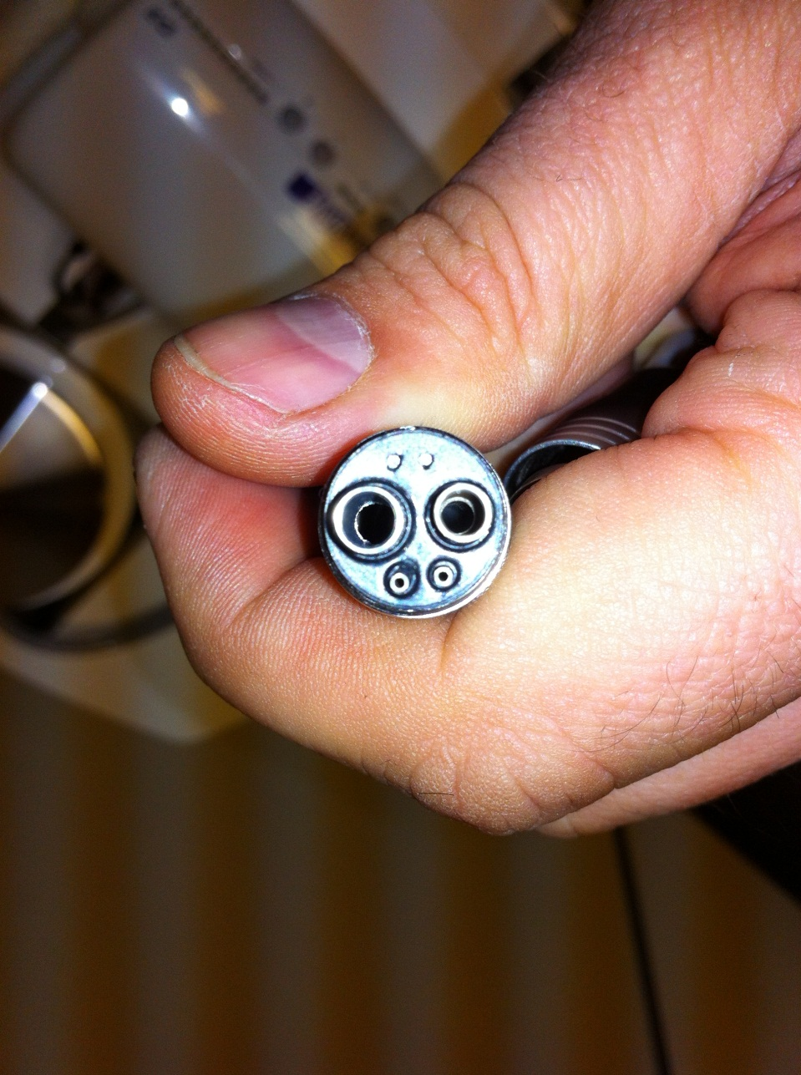

2-3 Drops of Air Motor Lubricating Oil

To clean the slow speed air motor use a disinfectant wipe over its entire surface. Do not submerge the motor in water or place it into an autoclave.

### (B) E-Fitting Slow Speed Straight Handpiece (Polisher Handpiece)

To attach a bur or angle attachment, turn the dial towards the top of the handpiece to release the chuck, insert the bur or prophy angle and turn in the opposite direction to lock it into place.

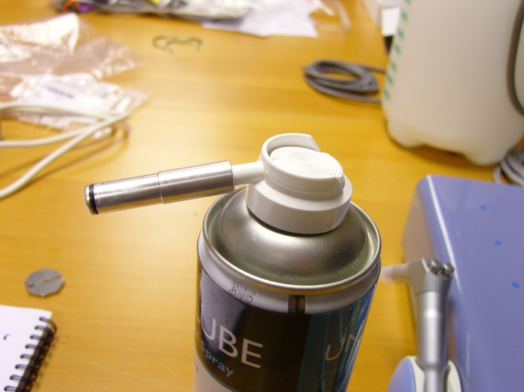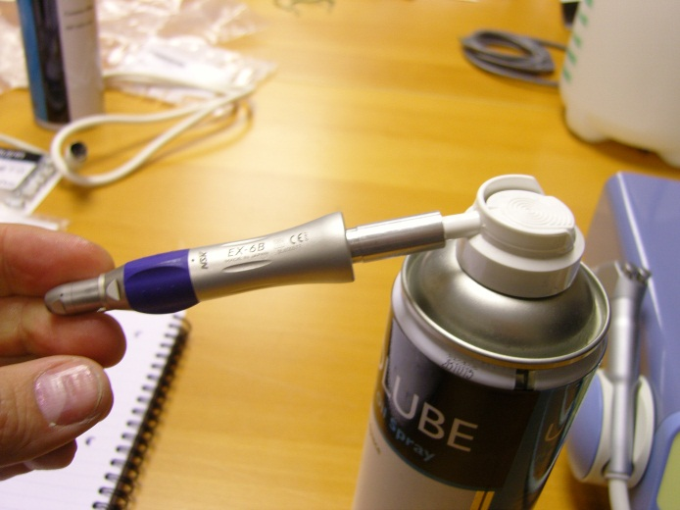

Always refer to the cleaning instructions supplied with each handpiece, as manufacturer advice may vary, but generally, the slow speed handpiece can be cleaned by first rinsing it under running water to remove excess debris before then using a disinfectant wipe over the surface of the handpeice.

The handpiece should then be oiled as detailed below.

As with the air motor, oiling of the handpiece is also of extreme importance and should be done using a proprietary oil spray designed for micromotor driven handpieces (Universal oil spray - Code DDS001)coupled with a suitable nozzle adaptor (Intra-Quick nozzle - Code NOZZ002). This enables a continuous high-pressure blast of oil which will efficiently clean and lubricate the handpiece.

The handpiece should be oiled before/ during each use. The dental bur or prophy angle should be removed and the oil nozzle inserted all the way into the base of the handpiece. It is then advised to spray the oil until it runs through clear - ideally this should be done over a sink or paper towel (away from the patient).

A spare bur, blank or prophy angle should then be inserted into the end and the handpiece should be run over the sink or paper towel to remove any excess oil.

After cleaning and oiling, the slow speed handpiece can then be placed in the autoclave at 134°C (do not use a drying cycle). *NOTE: All handpieces/ attachments should be placed inside an autoclave pouch to prevent oil from contaminating/ damaging your autoclave. Following sterilisation, allow to cool and then re-oil.*

### (C) High Speed Turbine Handpiece

Before explaining the maintenance for a turbine handpiece, it is first important to understand its operation.

When a high speed handpiece is running, it exhausts air from the top and bottom of the head. However, when the user lifts off the foot pedal the physics of the handpiece are altered as it slows down. The turbine starts to aspirate air around the head, drawing in materials such as tooth debris, blood and other fine particles.

For this reason, it is important not to run a highspeed handpiece without a bur/ drill in situ. This to prevent any debris from being aspirated into the handpiece when the foot pedal is lifted. Also, if handpieces are operated without a drill/ bur in place, the mechanics may become altered/ misaligned.

If the handpiece is not appropriately cleaned prior to autoclaving, a build-up of debris will occur around the turbine, which will become welded to the internal mechanisms. This will result in premature failure of the handpiece and possible damage to the dental unit itself.

After finishing each procedure the bur should be removed and discarded. The handpiece should then be rinsed under running water to remove any gross debris. It is also advisable to wipe the outside of the handpiece with a disinfectant wipe. The handpiece can then be oiled (see below), autoclaved and re-oiled. Please autoclave at 134°C with no drying cycle. *NOTE: all handpieces/ attachments should be placed inside an autoclave pouch to prevent oil from contaminating/ damaging your autoclave and should be cool before re-oiling. You should also remove any burs from the handpiece prior to placing them in the autoclave to avoid them getting stuck*

Human dentists use a fresh, fully cleaned and autoclaved handpiece between patients because of the huge risk of cross contamination of HIV. Vets should also consider cross contamination – particularly for FIV in cats. We would recommend that you should have 3 handpieces (one in use, one in the autoclave and one cooling down ready for the next patient).

The Air-Wave III LED dental system uses the popular 4-hole Midwest configuration. To oil the handpiece, unscrew from the hose and then place 2-3 drops of oil into the air drive port which is the smaller of the two larger holes on the right hand side, as indicated.

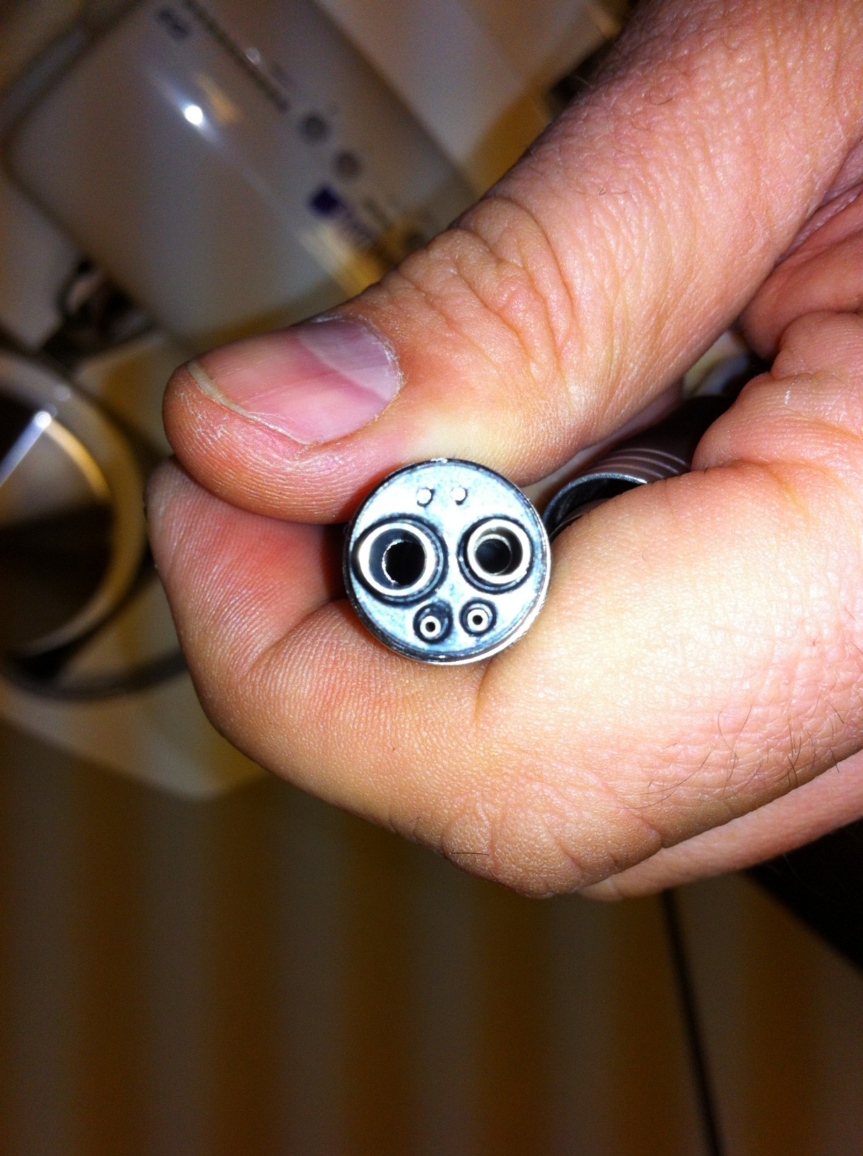

2-3 Drops of Turbine Lubricating Oil

After oiling, invert the handpiece and leave it to stand to allow the oil to run down into the turbine head. Oiling should be carried out with a blank/ bur in situ to keep the oil within turbine head. Be sure to rotate the bur forwards and backwards a few times to lubricate the mechanism fully.

Reconnect the airline and run for 6-10 seconds (away from patient) to remove any access oil before continuing with the dental procedure.

Please note, it is important that the highspeed handpiece is oiled during use and not just at the end of the day following cleaning. The advice from the manufacturer is that the highspeed handpiece should be oiled for every 15 minutes of use!

Again, for this reason we would recommend having multiple handpieces available.

(D) Prophy Angle

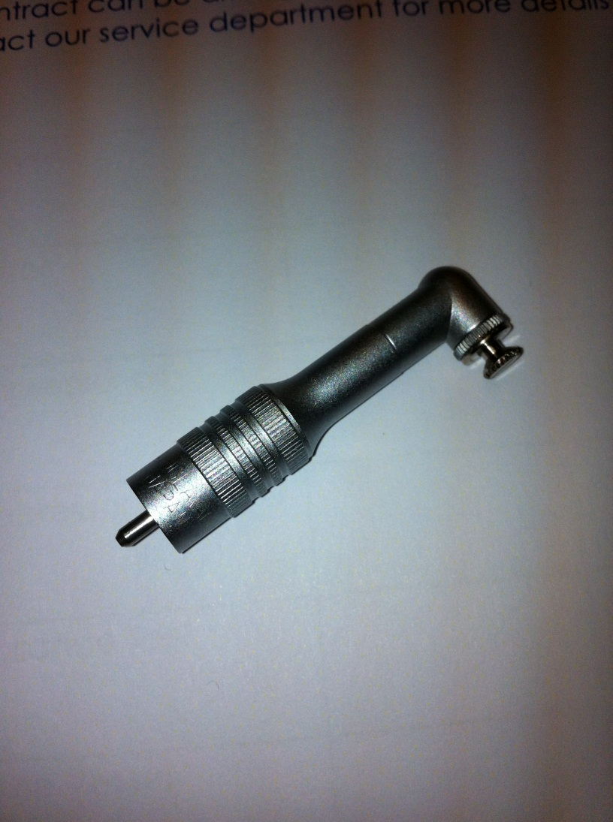 

This is a semi-disposable head attachment that fits on to an E-Fitting Slow Speed Straight Handpiece. The prophy angle accepts prophy cups directly on to the turning cap. Using prophy paste is a messy job; in time, the paste will gradually infiltrate the head wearing out the mechanism and dramatically shortening its working life. As the prophy angle is relatively cheap (around £20 or less) it is designed to be replaced on a regular basis. However, you can prolong the working life of the prophy angle by ensuring it is cleaned and oiled regularly. Generally, the prophy angle will last 6 to 12 months or more, if appropriately maintained.

Daily maintenance: After each use, remove the prophy cup and then remove the head cap by turning the ridged outer ring clockwise. Remove all foreign particles from gear head cavity and gear components. Now, lubricate all gear components and head cavity with a few drops of handpiece oil. Reassemble, making sure the gear cogs have realigned correctly and turn the shaft a few times to check the head cap still rotates. Wipe off any excess oil and run the prophy angle for 6-10 seconds (away from patient) to remove any excess oil before continuing with the dental procedure.

As with the other handpieces, the prophy angle can be autoclaved and then re-oiled. Please autoclave at 134°C with no drying cycle. *NOTE: all handpieces/ attachments should be placed inside an autoclave pouch to prevent oil from contaminating/ damaging your autoclave and should be cool before re-oiling.*

(E) 3-in-1 syringe

The 3-in-1 syringe (comprised of the syringe handpiece and the syringe tip) provides water, air or a combination of both. Press one button for water, one button for air, or both buttons together for a mist.

The syringe handpiece and tip require cleaning but not lubrication. To remove the syringe tip, press the outer ring around the base of the syringe tip, and then gently pull the tip out. The syringe tip can be rinsed under water, cleaned with general instrument cleaning solution (at the appropriate dilution) and then autoclaved at 134°C.

You must not submerge the syringe handpiece in water. To clean the syringe handpiece, use a disinfectant wipe to carefully clean all surfaces and in/ around the buttons.

**REMEMBER THE FOUR GOLDEN RULES OF MAINTENANCE:**

**CLEAN, LUBRICATE, STERILISE, RE-LUBRICATE**

# Daily Shut-Down Instructions

To prevent damage to your water bottle, it is important to depressurise (and drain) the water bottle at the end of each day. This can be done by setting the water supply switch to off (Fig. 6) and shutting off the isolation valve (Fig. 5), then press the air button on the 3- in-1 syringe to release any air left in system. Gently unscrew the water bottle from the housing, and empty the bottle. Once you have reattached the bottle, remember to turn the isolation valve back to the on position (vertical/ pointing down - Fig. 5) ready for the next use. PLEASE NOTE: Failure to turn the isolation valve back to the on position will mean that there will be no air to your handpieces and they will cease to function.

Always disconnect your Air-Wave III LED dental system (scaler and compressor) from the mains electrical supply each evening, or when not in use.

# Weekly Compressor Maintenance

Once a week it is important to drain the compressor tank of residual water.

Ensure thecompressor receiver tank pressure dial (Fig. 5) is depressurised to 2-Bar, prior to attempting this procedure. This can be achieved by turning off the electrical supply and operating a handpiece, or the 3-in1 syringe to use up the air in the tank. The drain valve is located on the underside of the tank as pictured below. Place a jug or other container under the outlet of the valve then turn the lever 90° to an open position (see photos below). When satisfied that all the air/water has been removed remember to close the valve to ensure it is ready for the next use. *NOTE: if the drain valve is left open and the compressor is turned on, the compressor will constantly try to reach pressure whilst the air is escaping through the open valve. This will cause the compressor to overheat and could potentially break it.

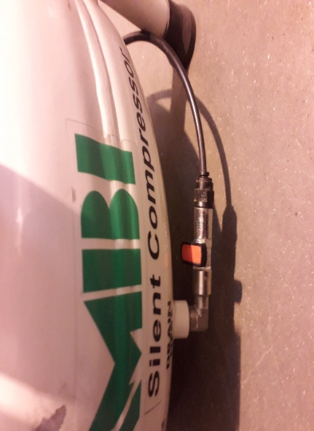 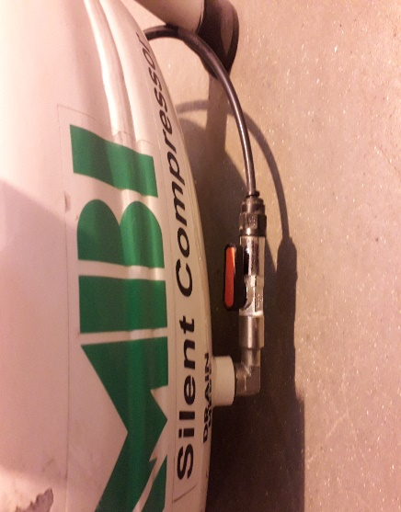

Valve closed Valve open

You should also check the oil level in the sight glass once per week. To be able to see the sight glass clearly, you may need to pull the compressor out of the chassis. If the oil level is below that which is illustrated (halfway point), pour **Bambi** compressor oil **slowly** into the oil inlet (illustrated below) until the correct level is obtained.

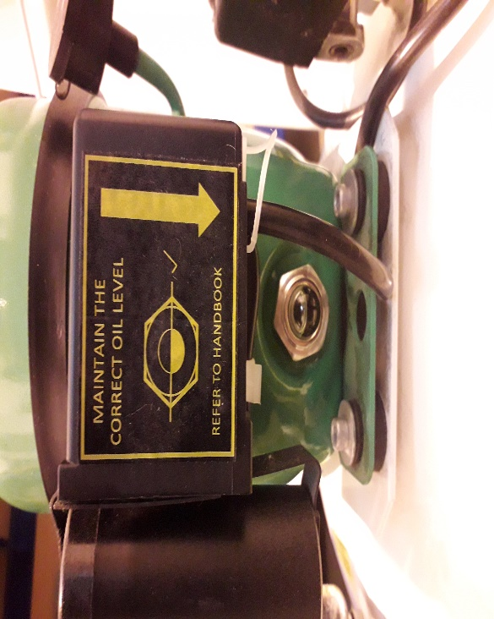 

# Air-Wave III LED Dental System Routine Maintenance Schedule

|  |  |  |  |
| --- | --- | --- | --- |
| Operation | Daily | Weekly | Annually(at yearly service) |
| Clean & lubricate all handpieces: E-Fitting Slow Speed Straight Handpiece (Polisher Handpiece),  High Speed Turbine Handpiece and Prophy Angle | 🗹 |  |  |
| Clean & lubricate Slow Speed Air Motor | 🗹 |  |  |
| Clean 3-in-1 syringe | 🗹 |  |  |
| Drain & depressurise  water bottle | 🗹 |  |  |
| Check compressor oil level |  | 🗹 |  |
| Drain air compressor tank |  | 🗹 |  |
| Change compressor oil |  |  | 🗹 |
| Replace compressor air intake filter |  |  | 🗹 |
| Portable Appliance Test |  |  | 🗹 |
| Renew Pressure Vessel Certificate |  |  | 🗹 |

For further information or in case of breakdown please contact our Service and Repairs department for assistance: **0800 068 3300 – Option 2.**